Project 1 Preliminary Plan

Eric Miao

47163991

* **Interface design and description of user controls (range, what they control)**

For image A, I will create two trackbars that control the cutoff of dog’s low frequency image and the cutoff of the cat’s high frequency image. This way we (users) can see the blending effect through moving the bar. (range 0-100%)

For Image B, I will have two trackbars that control the cutoff of the magnitude of zebra image and the cutoff of the phase of cheetah image. (range 0-100%)

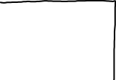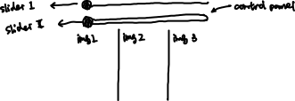

* **General system description of your approach to filtering including all processing steps. This can be expressed as mathematical equations, block diagram, pseudocode**

For Image A, it's looks like it is a combination of dog's low-frequency + cat’s high-frequency.

Cat high frequency = Original Cat – Cat (low-frequency)

Dog low frequiency = phase of the original image using dft()

For each channel:

newImg(channel) = Cat high frequency(channel) + Dog low frequiency(channel)

For Image B, I would do some color enhancement on both original images and then convert them to grayscale images. After that, I would combine the magnitude of zebra image and the phase of cheetah.

For filters in this program, I will be using dft() and kernel filter. And for color models, I will be using 3 channels Mat for creating image A and 1 channel grayscale Mat for creating image B.

* **Discussion of outstanding questions, issues and possible changes**

Will doing some image color enhancement (or reduction) improve the blending quality after?